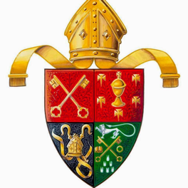
Senior Bishop’s Medal

Students in Secondary Education
5th & 6th Year Students

Competition Requirements: The competition is open to anyone attending a secondary school within the United Diocese. Competitors are not required to be members of the Church of Ireland nor attend a Church of Ireland school. Candidates are asked to write (in 75 minutes) an essay from a list of unseen titles. The competition places an emphasis on current affairs in church and society
.
Competition Date: 7pm Wednesday 9th March 2016 at all venues.

Venues: Kilkenny College OR Coláiste Bhride, Carnew OR Newtown School, Waterford

Applications and Further Information: Further details are available on the diocesan website (http://cashel.anglican.org/) or by contacting Canon Harvey directly.
The Revd Canon Patrick Harvey,
The Rectory, Abbeyleix, Portlaoise, Co Laois.. Applicants may also email patrickharveyone@gmail.com or telephone (057) 8731243
Application Closing Date: 5pm Tuesday 8th March 2016
(please note extended deadline)

